**Highland Academy**

**Academic Policy Committee**

JANUARY 18, 2024 Minutes

5:30-7:00

**Zoom Information:**

<https://asdk12.zoom.us/j/2314599803?pwd=eGNTbVE5eU9mV251a3NHeUdDVVRrQT09>

Meeting ID: 231 459 9803

Passcode: phoenix

| **Cyclical Resources:** | **Resources for this meeting:** |
| --- | --- |
| [HACS APC Running Agenda Items Calendar](https://docs.google.com/document/d/1_Ye7-BOqfsiGPZvm3PE86QT969qwc6iOvctsG59liTY/edit#heading=h.ln7kmthxyxcp)  [Highland Collaborative Leadership Compact](https://docs.google.com/document/d/1VPn_wd-cktlWRWREhlvgxSyT13ZhsPtjSRQrGnSPFsw/edit#heading=h.centuepgsh7b)   * [APC Calendar](https://docs.google.com/spreadsheets/d/1G6TKFqSs3NkJlgwUvpCisl70aCj3nKCaZTZHH095sQ4/edit#gid=422462332) * [APC Main Folder](https://drive.google.com/drive/folders/1NGJfz4Rk_l2CuOlhqX1WP3nArMb9I0y1?usp=sharing) * [SY2024 Goals All in One](https://docs.google.com/document/d/1yQ60N9gqwHLMPzpI-bIu0pxUhMnIfsH68cAAv0eRFwM/edit?usp=sharing) * [Current Board Roster](https://docs.google.com/document/d/1UEp0Z6qIebBQ9x8XblanTmo70WTvHBb57etXfu1C6wg/edit) * [By-Laws](https://docs.google.com/document/d/1eJ4Z9PIikI-wuZNOHdPovum2XCzE1QW8/edit) | * [December 2023 APC Minutes](https://docs.google.com/document/d/1aWJ6ppoy39l3uLBzN2ncj-v8qegUMYYvnCDFOvY6YLc/edit?usp=drive_link) * [By-Laws](https://docs.google.com/document/d/1eJ4Z9PIikI-wuZNOHdPovum2XCzE1QW8/edit) * [Performance Committee Action Plan](https://docs.google.com/document/d/1an7jlZWExYDH0hbzg7qgl_A5dtJjW9tbuu6JVpXEVj4/edit) |

**Agenda**

1.Determination of Quorum and Call to Order *@ 5:34pm Laura Hilger, Philippe Janicka, Nicole Crosby, Jill Harter, Robin Brosius, Jason Hlasney, Kelly Daugherty, Meghan Cunningham*

2.Land Acknowledgement:

**Please join me by acknowledging that we all live and work on the land of the Dena’ina people:**

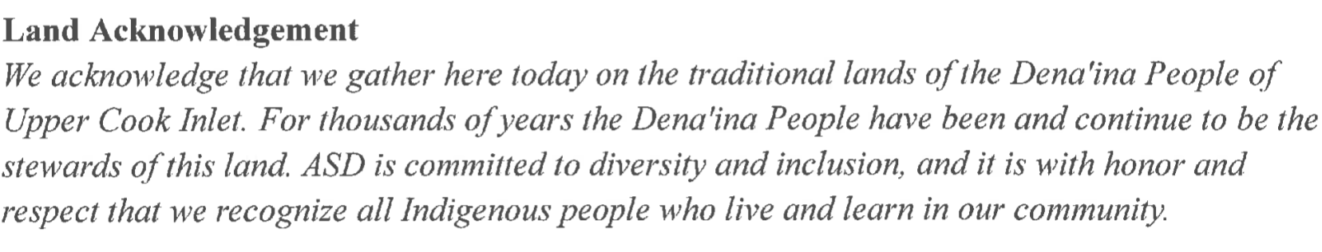

3. Clarifications on Agenda and Set Intentions

4. Approval of the DECEMBER minutes *Jill* *moved to approve, Meghan seconded, motion carried unanimously*

5. Public comment

6. Principal Report

* **NON-ACTION:**
  + **Data (Progress Reports, MAP, Cell Phone)**
  + **Recruitment Efforts**
  + **Counselor information**

7. Meeting the mission of the Charter

* **PTSO Liaison Report Out**
* **Committee Updates**
  + Committee Report Outs
  + Goal Committee Workshop
    - Schedule next committee meetings via our new APC Calendar
* **Begin annual By-Law Review for Revisions**

8. *Adjournment @7:06 pm*

**Next Board Meeting:** February 15, 5:30pm

Have any agenda items? Add to our [Running Agenda Items Calendar](https://docs.google.com/document/d/1_Ye7-BOqfsiGPZvm3PE86QT969qwc6iOvctsG59liTY/edit?usp=sharing)

*The APC reserves the right to enter into executive session as provided for in State Law on any agenda item. Executive sessions may be entered into for the following subjects as permitted by law: (1) matters the immediate knowledge of which would clearly have an adverse effect upon the finances of the District; (2) subjects that tend to prejudice the reputation and character of any person, provided that the person may request a public discussion; (3) matters which by law, municipal charter, or ordinance are required to be confidential; and, (4) matters involving consideration of government records that by law are not subject to public disclosure. Motions to go into executive session should specify the subject of the proposed executive session without defeating the purpose of addressing the subject in private.*